# CS 255 System Design Document Template

This template lays out all the different sections that you need to complete for Project Two. Each section has guidance to prompt your thinking. You will need to continually reference the interview transcript as you work to make sure that you are addressing your client’s needs. There is no required length for the final document. Instead the goal is to complete each section based on what your client’s needs are. Remove this note when you are finished, and replace all bracketed text with the relevant information.

## UML Diagrams

### UML Use Case Diagram

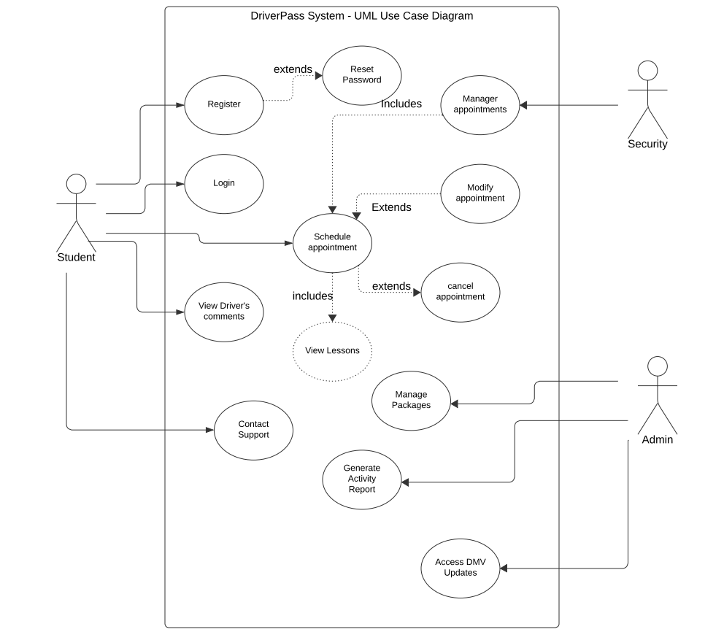

### UML Activity Diagrams

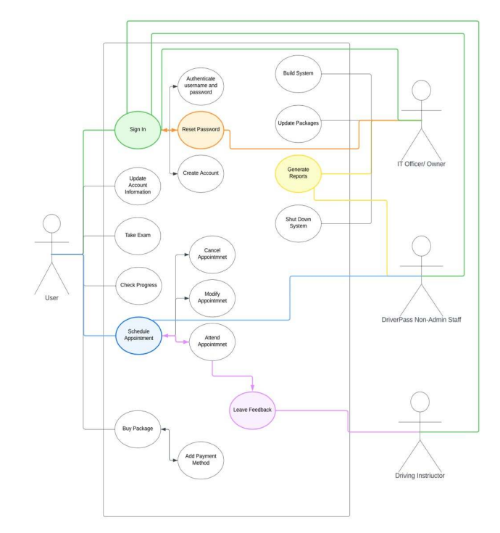

### UML Sequence Diagram

### UML Class Diagram

## Technical Requirements

*For the hardware, you will need a dedicated server, a reliable internet connection, sufficient storage for website and database data, a mobile or computer device for website access, and a firewall to protect the website’s ports.*

*Software requirements include using Windows servers for stability, deploying an SQL Server for database management, integrating backup solutions for the database and website to handle emergencies, and implementing security measures to guard against malware.*

*Geographic considerations involve ensuring the website's accessibility in the USA, securing the website and database in a data center, and positioning the server in a central location to optimize accessibility and performance.*